1. We can create our own Authorization Server using Spring Security but better if we go for already existing one such as GitHub.
2. Before using any existing one, register yourself with them by giving them some details like
   1. Client Name (Application Name).
   2. Redirect URI etc.
3. Then you will get Client ID and Client Secrete (password).
   1. These will be used inside the authorization and authentication flows.
4. So, to use Github authorization server, we have to be Github user.
5. **Steps to register**:
   1. 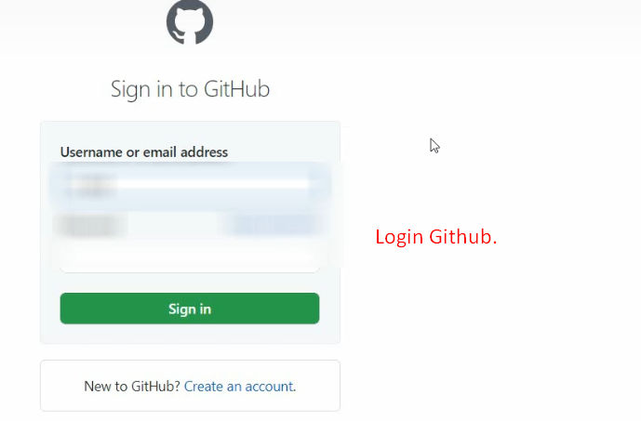
   2. 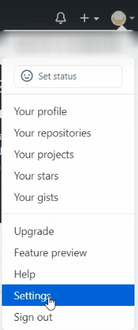
   3. 
   4. 
   5. 